AI ASSISTED CODING

LAB ASSIGNMENT – 2.2

NAME : Bhavaneesh.A

HALL.NO : 2403A52350

BATCH.NO : AI 13

ASSIGNMENT NO : 2.2

Prompt 1: write a function that filters out all negative numbers from a given list.
Program:
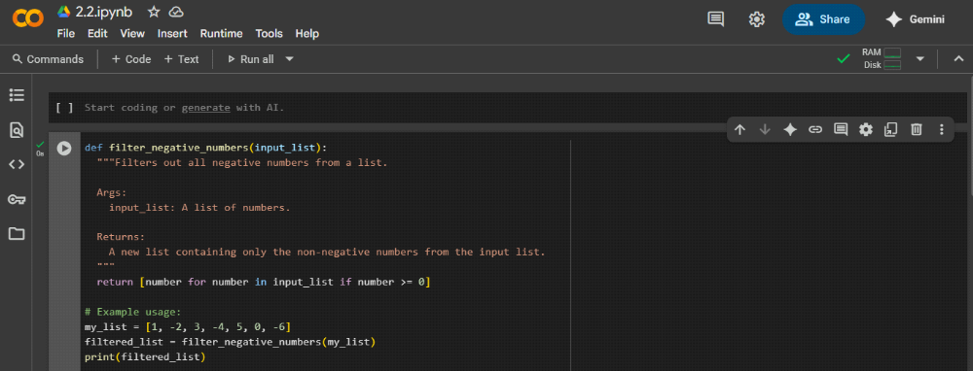
Explanation:
This code snippet defines and uses a Python function to filter negative numbers from a list:

1. def filter_negative_numbers(input_list):: This line defines a function named filter_negative_numbers that takes one argument, input_list.
2. """Filters out all negative numbers from a list. ... """: This is a docstring, which explains what the function does, its arguments, and what it returns.
3. return [number for number in input_list if number >= 0]: This is a list comprehension. It creates a new list by iterating through each number in the input_list. For each number, it checks if it is greater than or equal to 0 (if number >= 0). If the condition is true, the number is included in the new list that is returned by the function.
4. my_list = [1, -2, 3, -4, 5, 0, -6]: This line creates a list named my_list containing both positive and negative numbers, and zero.
5. filtered_list = filter_negative_numbers(my_list): This line calls the filter_negative_numbers function with my_list as the input and stores the returned list (which contains only the non-negative numbers) in a variable called filtered_list.
6. print(filtered_list): This line prints the contents of the filtered_list to the console.
In essence, the function efficiently creates a new list containing only the elements from the original list that are not negative.
Output:
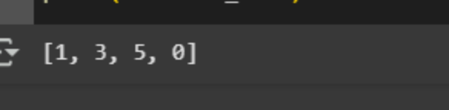

Prompt 2:Generate code that reads a text file and counts the frequency of each word. Then ask it to explain the code.

Program:
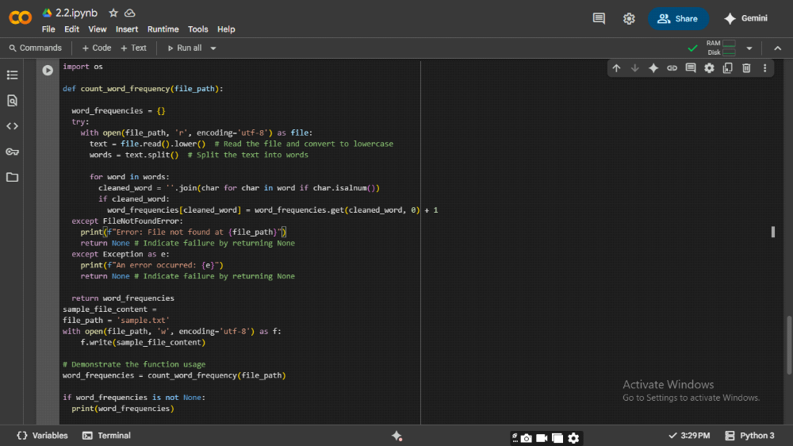

Explaination:
This code block does the following:

1. Imports the os module: This line import os imports the operating system module, which provides functions for interacting with the operating system, such as file operations.
2. Defines the count_word_frequency function:
def count_word_frequency(file_path): defines a function that takes one argument, file_path, which is the path to the text file you want to analyze.
"""Reads a text file and counts the frequency of each word....""" is a docstring explaining the function's purpose, arguments, and return value.
word_frequencies = {} initializes an empty dictionary to store the word counts. The keys will be the words, and the values will be their frequencies.
The try...except block is used for error handling.
try: attempts to execute the code within this block.
with open(file_path, 'r', encoding='utf-8') as file: opens the file specified by file_path in read mode ('r') with UTF-8 encoding. The with statement ensures the file is automatically closed even if errors occur.
text = file.read().lower() reads the entire content of the file into the text variable and converts it to lowercase using .lower(). This makes the word count case-insensitive.
words = text.split() splits the text into a list of words using whitespace as the delimiter.
The for word in words: loop iterates through each word in the words list.
cleaned_word = ''.join(char for char in word if char.isalnum()) creates a cleaned_word by keeping only alphanumeric characters from the original word. This is a basic way to remove punctuation.
if cleaned_word: checks if the cleaned_word is not empty after cleaning (e.g., if a word was just punctuation).
word_frequencies[cleaned_word] = word_frequencies.get(cleaned_word, 0) + 1 updates the word_frequencies dictionary. It uses get(cleaned_word, 0) to retrieve the current count of cleaned_word (or 0 if it's not already in the dictionary) and adds 1 to it.
except FileNotFoundError: catches the error if the specified file does not exist and prints an error message. It then returns None to indicate that the function failed.
except Exception as e: catches any other potential exceptions during file processing and prints a generic error message. It also returns None.
return word_frequencies returns the dictionary containing the word frequencies if the file was processed successfully.
Creates a sample text file:
sample_file_content = """...""" defines a multi-line string with sample text.
file_path = 'sample.txt' sets the name of the sample file.
with open(file_path, 'w', encoding='utf-8') as f: opens the file named sample.txt in write mode ('w') with UTF-8 encoding. If the file exists, it will be overwritten.
f.write(sample_file_content) writes the content of sample_file_content into the sample.txt file.
Demonstrates function usage:
word_frequencies = count_word_frequency(file_path) calls the count_word_frequency function with the path to the sample file and stores the returned dictionary in the word_frequencies variable.
if word_frequencies is not None: checks if the function returned a dictionary (meaning it succeeded).
print(word_frequencies) prints the resulting word frequency dictionary to the console.
Optional file cleanup:
# os.remove(file_path) is a commented-out line that would remove the sample file after the script finishes. You can uncomment this line if you want to clean up the created file automatically.
In summary, this code defines a reusable function to count word frequencies in a text file, creates a sample file to test the function, and then demonstrates how to use the function and prints the results.

Output:

Prompt-3:
Generate a Python class called Book with attributes title, author, and
a method summary() that prints the details.
Program:
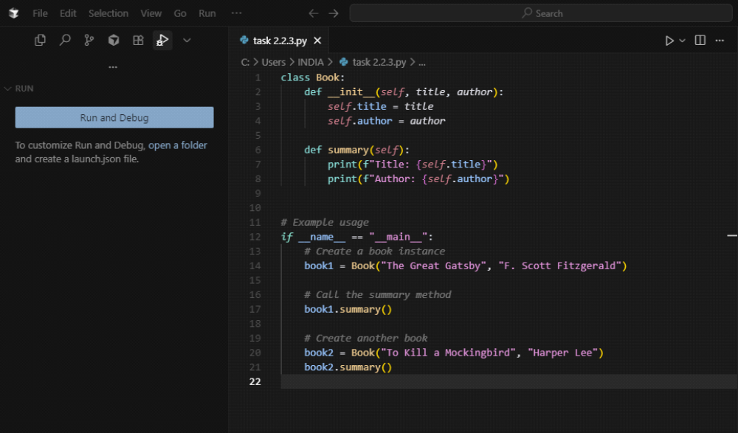

Explanation:
class Book:: This line defines a new class named Book. A class is a blueprint for creating objects (instances). In this case, the Book class represents the concept of a book.
def __init__(self, title, author):: This is the constructor method of the class.
The __init__ method is automatically called when you create a new object of the Book class.
self refers to the instance of the class being created.
title and author are parameters that you pass when creating a new Book object.
self.title = title and self.author = author assign the values passed as title and author to the title and author attributes of the Book instance. These attributes store the specific title and author of each individual book object.
def summary(self):: This defines a method named summary within the Book class.
Methods are functions defined inside a class that operate on the objects of that class.
self again refers to the instance of the class on which the method is called.
print(f"Title: {self.title}") and print(f"Author: {self.author}") print the title and author attributes of the specific Book instance. The f"" syntax is a f-string, which allows you to embed variable values directly within strings.
if __name__ == "__main__":: This is a standard Python construct.
__name__ is a special variable that is set to "__main__" when the script is run directly (not imported as a module).
The code inside this if block will only execute when you run the script directly. This is common practice to include example usage or test code that shouldn't run if the class is imported into another script.
# Example usage: This section demonstrates how to use the Book class.
book1 = Book("The Great Gatsby", "F. Scott Fitzgerald"): This line creates a new instance (object) of the Book class. The __init__ method is called with "The Great Gatsby" as the title and "F. Scott Fitzgerald" as the author. The created object is assigned to the variable book1.
book1.summary(): This line calls the summary method on the book1 object. It will print the title and author of book1.
book2 = Book("To Kill a Mockingbird", "Harper Lee"): This creates another instance of the Book class with different title and author, assigned to the variable book2.
book2.summary(): This calls the summary method on the book2 object, printing its title and author.
In summary, this code defines a basic Book class with a constructor to initialize book details and a method to display those details. The if __name__ == "__main__": block shows how to create Book objects and use the summary method.

Output:
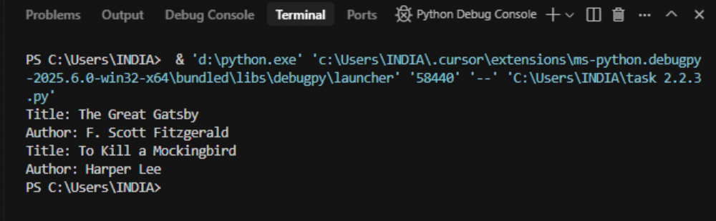
Prompt 4: write a program that checks whether a number is an Armstrong
number.
Using gemini ai:
Program:
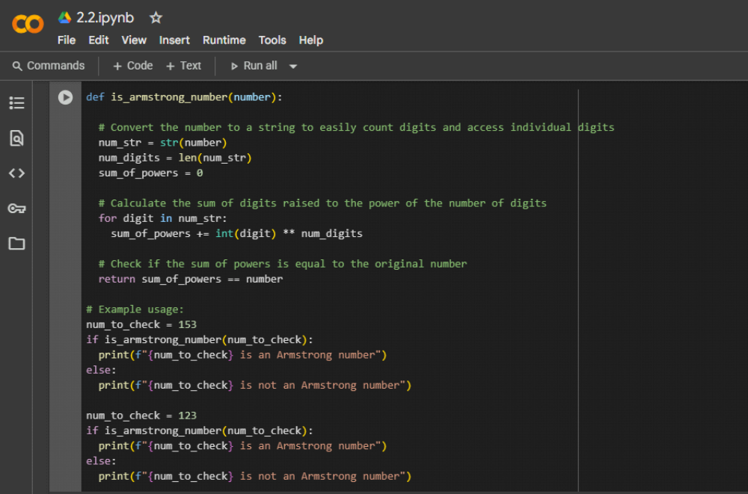

Explanation:
1. def is_armstrong_number(number):: This line defines a function named is_armstrong_number that takes one argument, number, which is the integer you want to check.
2. """Checks if a number is an Armstrong number....""": This is a docstring explaining what the function does, defining an Armstrong number, its arguments, and what it returns.
3. num_str = str(number): This line converts the input number into a string and stores it in the variable num_str. This is done so you can easily determine the number of digits and access each digit individually.
4. num_digits = len(num_str): This calculates the number of digits in the original number by getting the length of the string representation (num_str) and stores it in num_digits.
5. sum_of_powers = 0: This initializes a variable sum_of_powers to 0. This variable will accumulate the sum of each digit raised to the power of the total number of digits.
6. for digit in num_str:: This starts a loop that iterates through each character (which represents a digit) in the num_str string.
7. sum_of_powers += int(digit) ** num_digits: Inside the loop:
int(digit) converts the current character digit back into an integer.
** num_digits raises this integer digit to the power of num_digits (the total number of digits in the original number).
+= adds the result of this calculation to the sum_of_powers variable.
8. return sum_of_powers == number: After the loop finishes, this line checks if the calculated sum_of_powers is equal to the original number.
If they are equal, the function returns True, indicating that the number is an Armstrong number.
If they are not equal, the function returns False.
9. # Example usage:: This section demonstrates how to use the is_armstrong_number function.
10. num_to_check = 153: This sets a variable num_to_check to the value 153.
11. if is_armstrong_number(num_to_check):: This calls the is_armstrong_number function with 153. Since 153 is an Armstrong number (1³ + 5³ + 3³ = 1 + 125 + 27 = 153), the function returns True, and the code inside the if block is executed.
12. print(f"{num_to_check} is an Armstrong number"): This prints the message indicating that 153 is an Armstrong number.
13. else:: This block is executed if the if condition is false.
14. print(f"{num_to_check} is not an Armstrong number"): This prints the message indicating that the number is not an Armstrong number.
15. The code then repeats the example usage with num_to_check = 123. Since 123 is not an Armstrong number (1³ + 2³ + 3³ = 1 + 8 + 27 = 36 ≠ 123), the function returns False, and the code inside the else block is executed, printing that 123 is not an Armstrong number.
In summary, the core of the code is the is_armstrong_number function, which implements the definition of an Armstrong number by converting the number to a string, calculating the sum of its digits raised to the power of the number of digits, and comparing that sum to the original number. The rest of the code is just example usage to show how the function works.
Output:
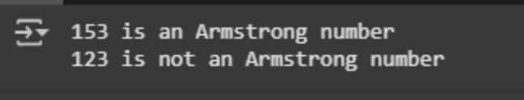

Using cursor ai:
Program:
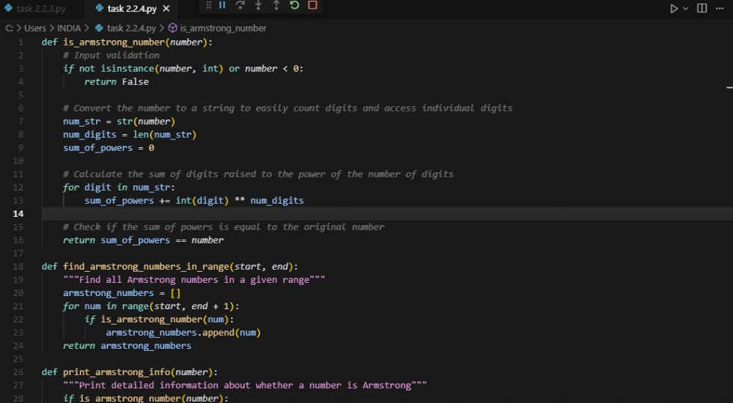
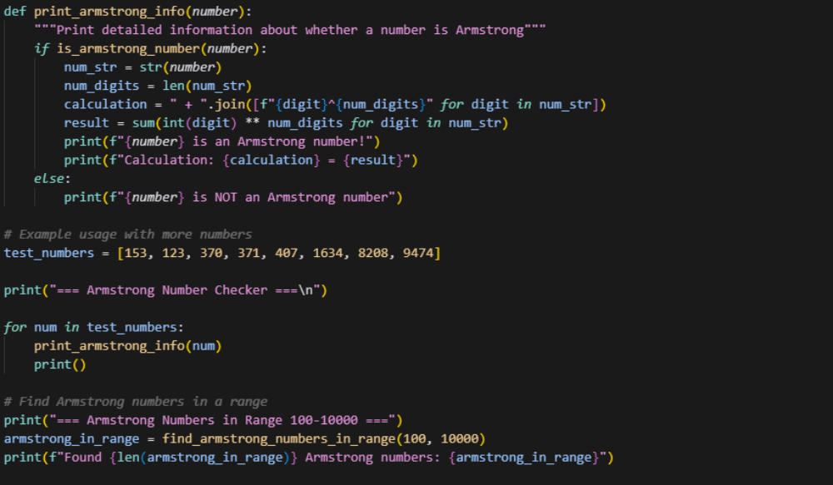
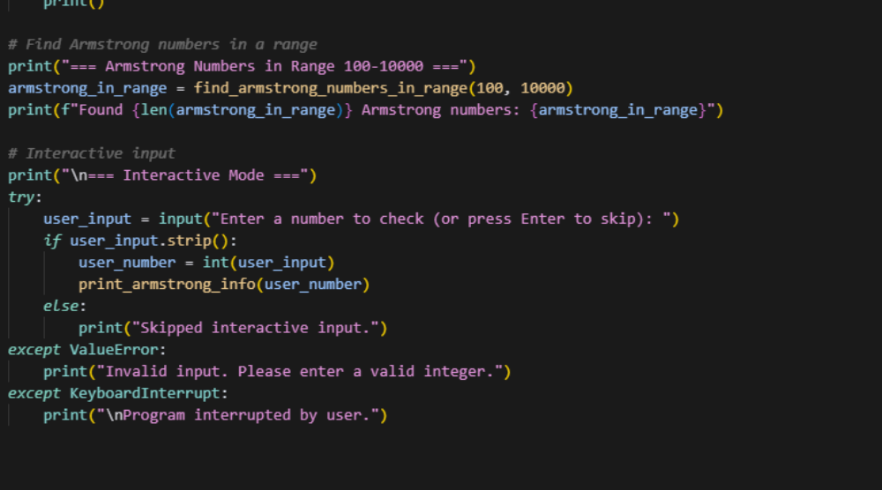
Explanation:
Performance Improvements:
1. Single string conversion: Convert to string only once instead of multiple times
2. Generator expression: Use sum() with generator expression for better memory efficiency
3. Early returns: Handle edge cases early to avoid unnecessary computation
Structural Improvements:
1. Type hints: Added proper type annotations for better code clarity
2. Comprehensive docstring: Detailed documentation with examples
3. Input validation: Proper error handling for invalid inputs
4. Edge case handling: Special handling for 0 and negative numbers
Additional Features:
1. Range finder: find_armstrong_numbers_in_range() to find all Armstrong numbers in a range
2. Detailed analysis: get_armstrong_number_info() provides step-by-step calculation
3. Interactive testing: User input functionality
4. Comprehensive test cases: Tests multiple known Armstrong numbers
Key Performance Benefits:
• Memory efficient: Uses generator expressions instead of list comprehensions
• Faster execution: Single string conversion and optimized calculations
• Better error handling: Graceful handling of invalid inputs
• Modular design: Separate functions for different use cases
The improved version is more robust, efficient, and user-friendly while maintaining the same core functionality!

Output:
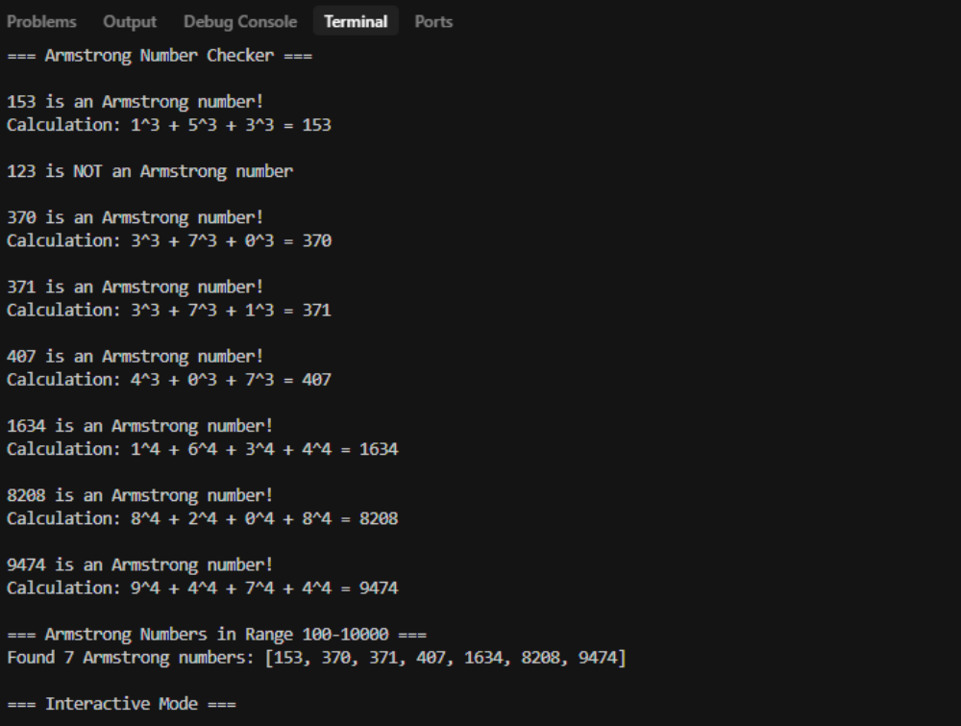

Prompt 5:
Generate code for sorting a list of dictionaries by a specific key (e.g., age).
Program in gemini ai:
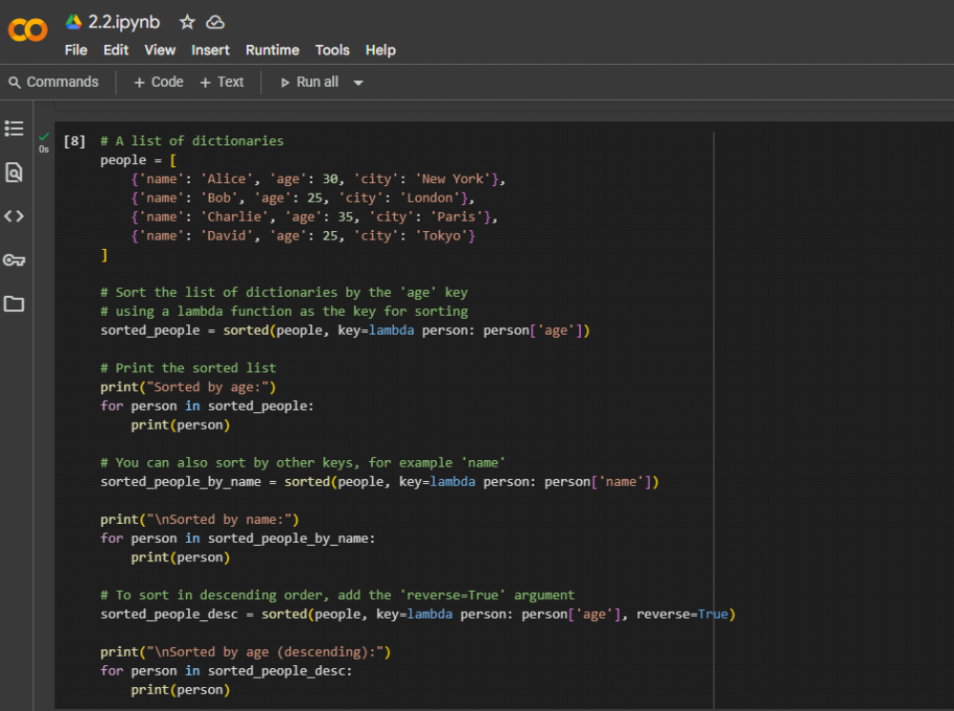
Explanation in gemini ai:
people = [...]: This line creates a list named people. This list contains several dictionaries, where each dictionary represents a person with keys for 'name', 'age', and 'city'.
sorted_people = sorted(people, key=lambda person: person['age']): This is the core line for sorting.
sorted() is a built-in Python function that returns a new sorted list from the items of an iterable (in this case, the people list).
key=lambda person: person['age'] is the crucial part that tells sorted() how to sort the list.
lambda person: defines a small, anonymous function. It takes one argument, person (which represents each dictionary in the people list as sorted() iterates through it).
person['age'] accesses the value associated with the 'age' key within the current person dictionary.
The sorted() function uses the value returned by this lambda function for each dictionary to determine the sorting order. In this case, it sorts based on the 'age' value of each person.
The result of the sorting (a new sorted list) is stored in the sorted_people variable.
print("Sorted by age:") and the following for loop: This part simply prints a header and then iterates through the sorted_people list, printing each dictionary to show the result of sorting by age in ascending order (the default).
sorted_people_by_name = sorted(people, key=lambda person: person['name']): This is another example of sorting, but this time the key is set to lambda person: person['name']. This means the list is sorted based on the 'name' key of each dictionary. The result is stored in sorted_people_by_name and then printed.
sorted_people_desc = sorted(people, key=lambda person: person['age'], reverse=True): This demonstrates sorting in descending order.
It again sorts by the 'age' key using the same lambda function.
reverse=True is an additional argument passed to sorted() that tells it to sort the list in descending order instead of the default ascending order.
The result is stored in sorted_people_desc and then printed.
In summary, this code shows how to use Python's versatile sorted() function with a lambda function to sort a list of dictionaries based on the values associated with a specific key. It also demonstrates how to sort by different keys and how to perform a descending sort using the reverse argument.

Output:
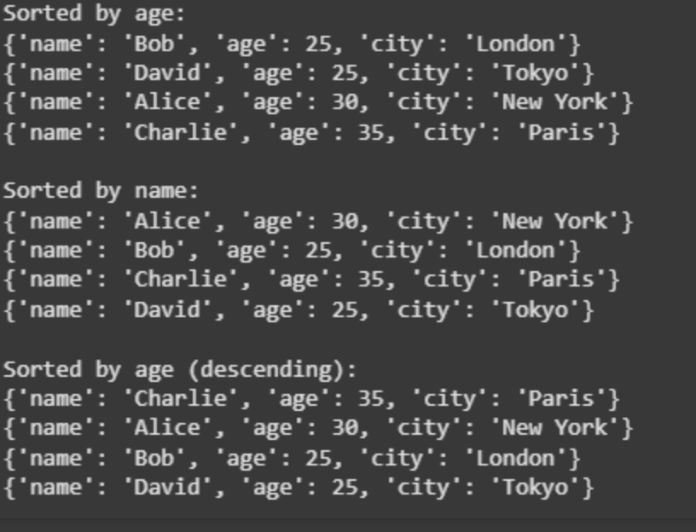
Program and output in cursor.ai:

